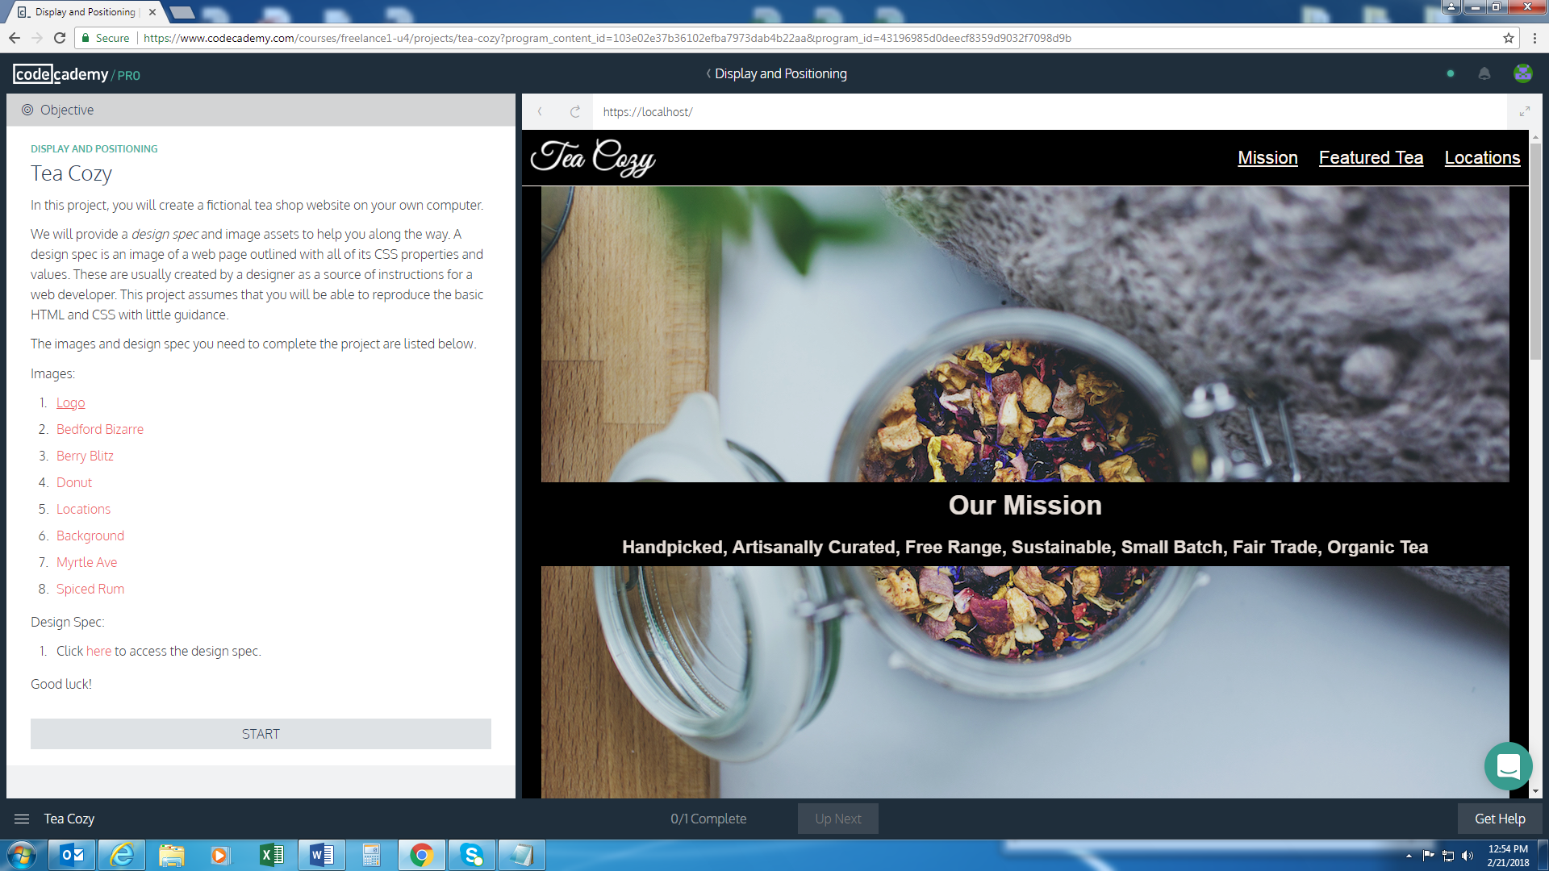

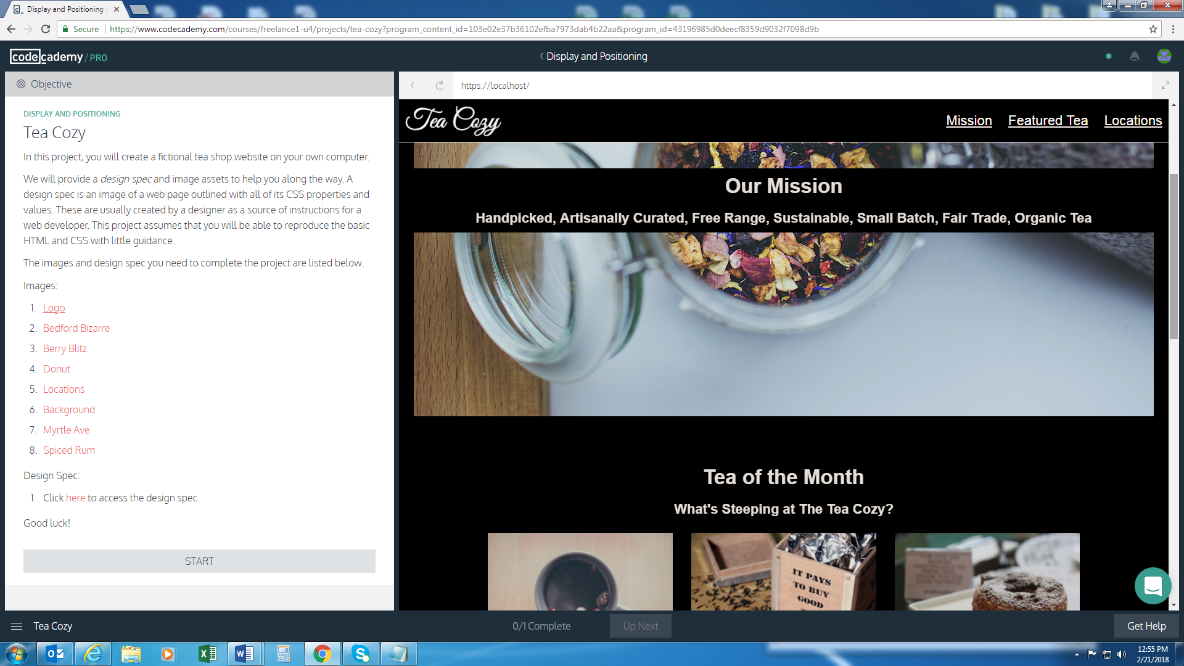

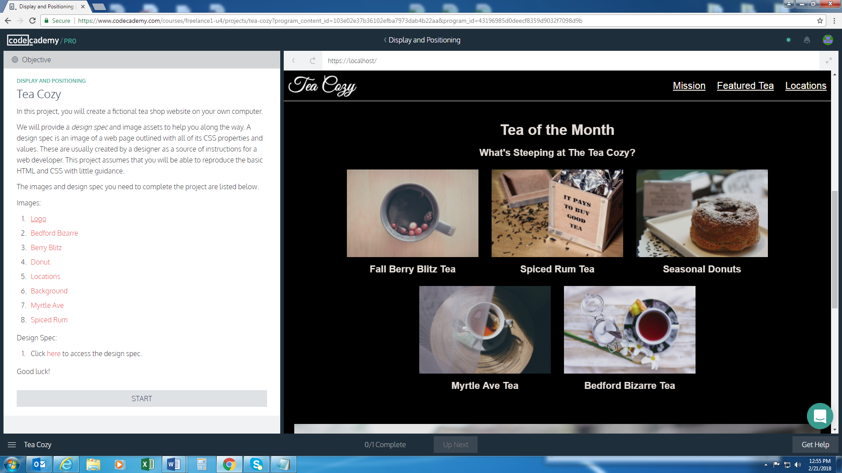

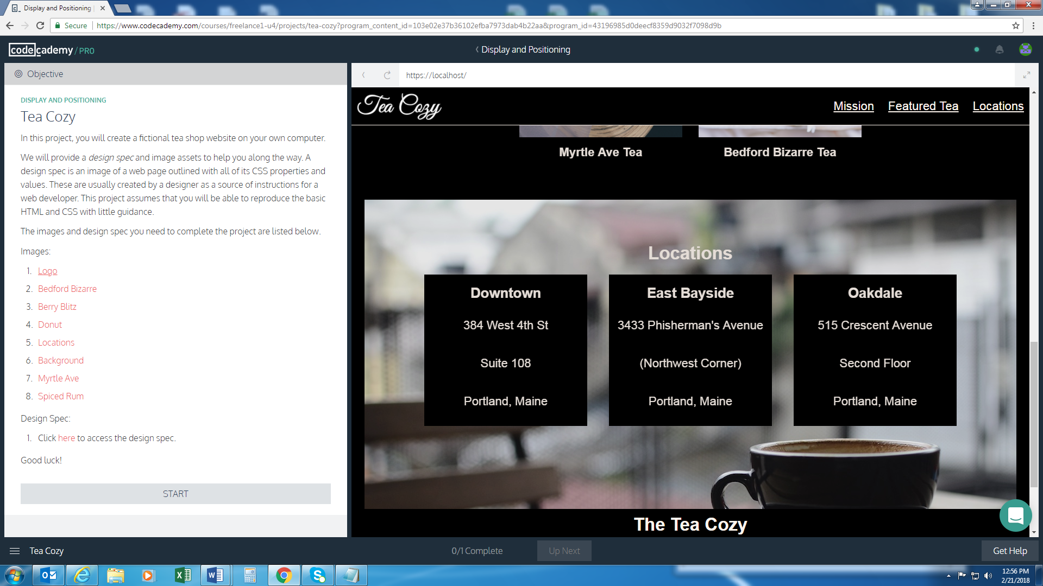

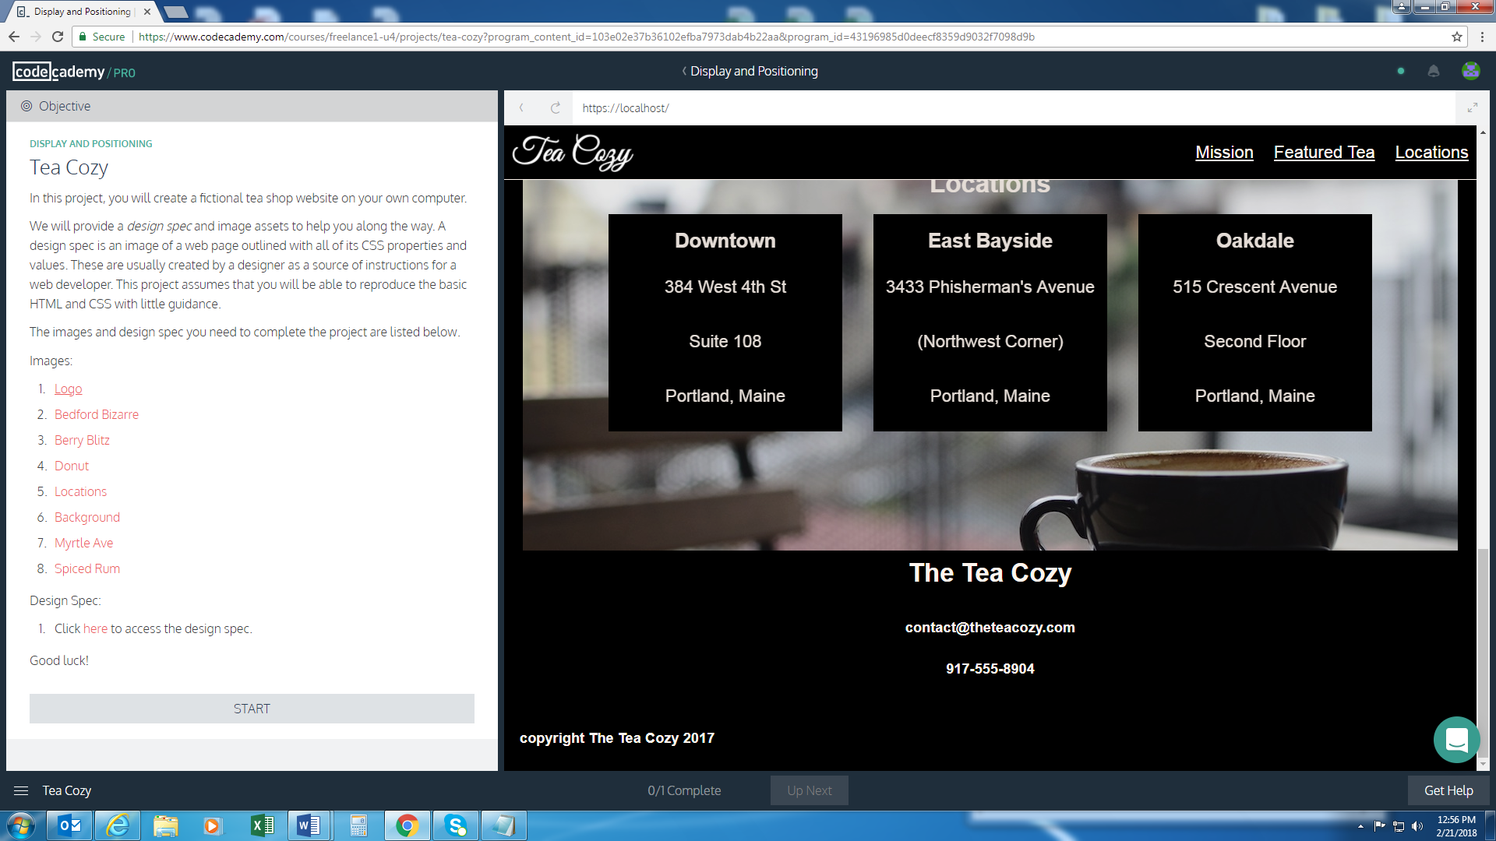

Footer Section equivalent

<div class=”section-5”>

.footer-1 {

display: flex;

flex-direction: column;

flex-wrap: wrap;

background: orange;

}

<div class=”footer-1-1”>

.footer-1-1 {

display: flex;

justifiy-content: center;

width: 1000px;

}

<div class=”footer-1-1-1”>

<p>The Tea Cozy</p>

<p>contact@theteacozy.com</p>

<p>917-555-8904</p>

</div>

<div class=”footer-1-2”>

.footer-1-2 {

Display: flex;

Justify-content: flex-start;

width: 1000px;

}

<div class=”footer-1-2-1”>

<p>copyright The Tea Cozy 2017</p>

</div>

**Design Spec**

